**AUTOMATIC ROOM LIGHTNING SYSTEM**

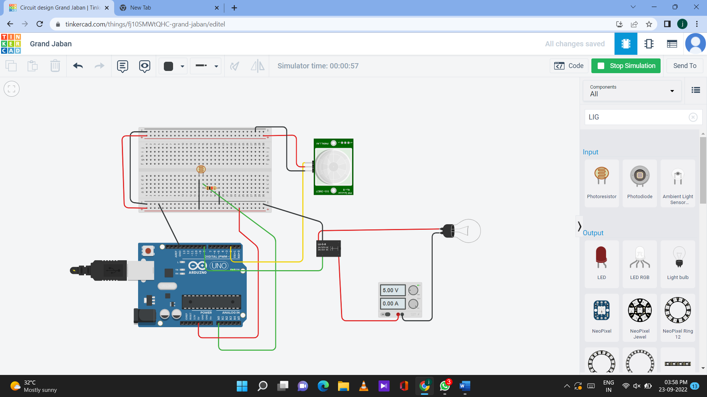

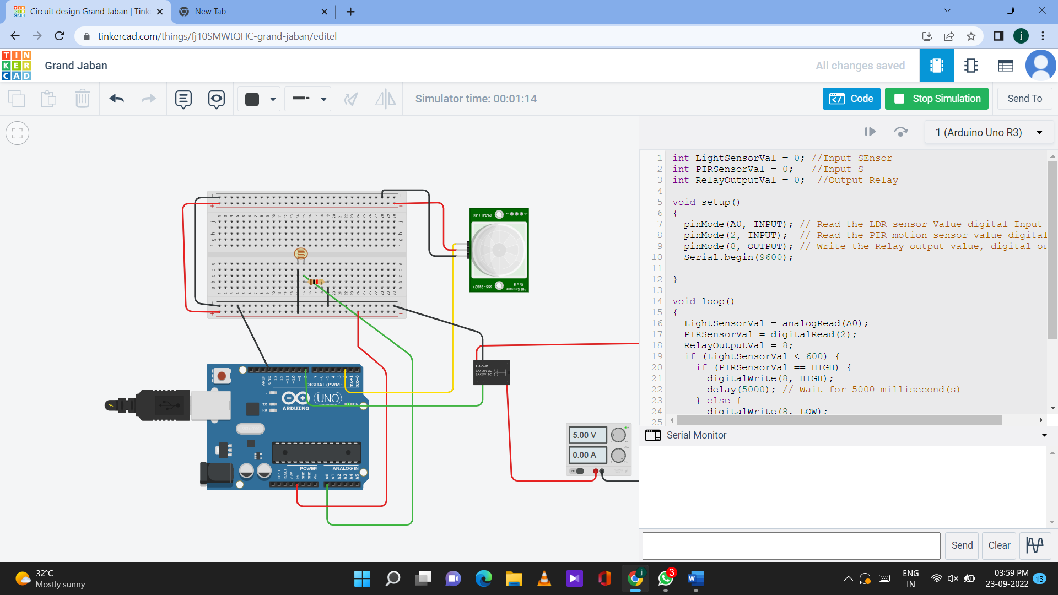

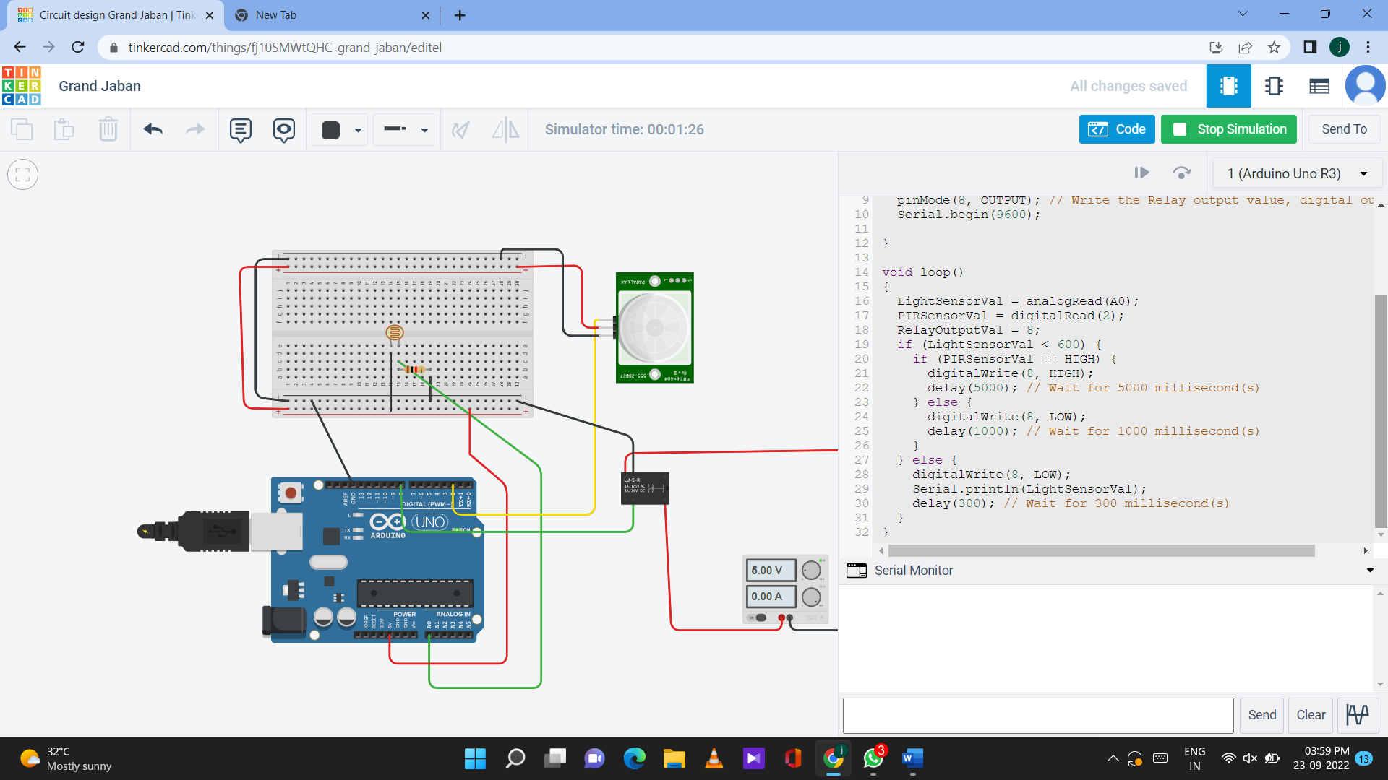

**CODE**

int LightSensorVal = 0; //Input SEnsor

int PIRSensorVal = 0; //Input S

int RelayOutputVal = 0; //Output Relay

void setup()

{

pinMode(A0, INPUT); // Read the LDR sensor Value digital Input

pinMode(2, INPUT); // Read the PIR motion sensor value digital Input

pinMode(8, OUTPUT); // Write the Relay output value, digital output

Serial.begin(9600);

}

void loop()

{

LightSensorVal = analogRead(A0);

PIRSensorVal = digitalRead(2);

RelayOutputVal = 8;

if (LightSensorVal < 600) {

if (PIRSensorVal == HIGH) {

digitalWrite(8, HIGH);

delay(5000); // Wait for 5000 millisecond(s)

} else {

digitalWrite(8, LOW);

delay(1000); // Wait for 1000 millisecond(s)

}

} else {

digitalWrite(8, LOW);

Serial.println(LightSensorVal);

delay(300); // Wait for 300 millisecond(s)

}

}